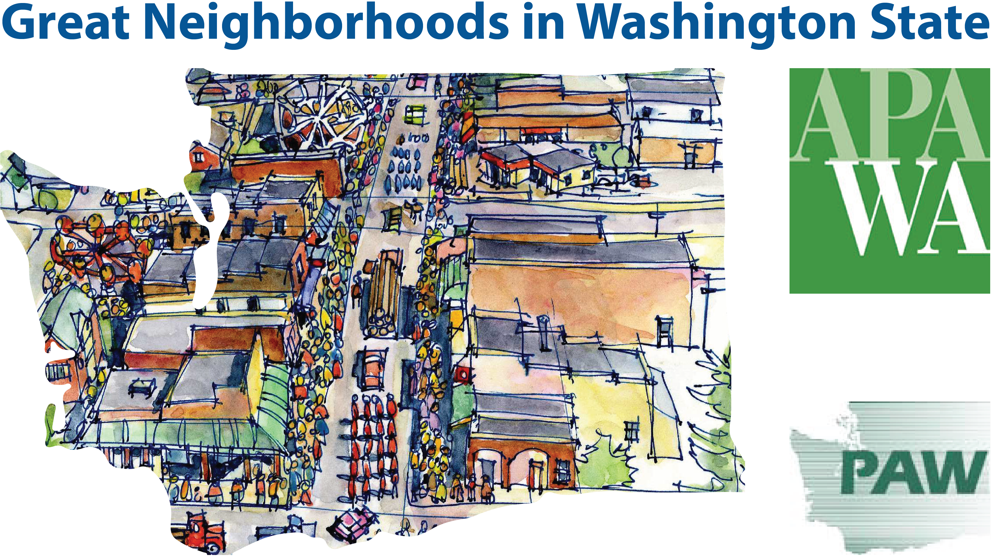
Nomination Form
Great Places in Washington Awards Program
An awards program co-sponsored by the Washington Chapter of the American Planning Association (APA WA) and the Planning Association of Washington (PAW)
Nominations Due: July 14
Please send a digital copy to office@washington-apa.org and a hard copy to Washington Chapter American Planning Association 2150 N 107th Street Ste 205, Seattle, WA 98133 postmarked by July 14. Submittals are limited to six pages total (including this cover page).
The 2017 Great Places in Washington Awards program will recognize Great Neighborhoods in Washington State. Awards this year will be given to two neighborhoods — one in Western Washington and one in Eastern Washington. This program is based on the American Planning Association’s Great Places in America Program (www.planning.org/greatplaces/).
Who Should Apply?
All are welcome to apply. Examples include cities and towns, community/neighborhood groups, Chambers of Commerce, and planning professionals.
Great Neighborhood Awards Criteria:
A neighborhood can be based on a specific plan or the result of a more organic process. Neighborhoods of different kinds are eligible — downtown, urban, suburban, exurban, town, small village — but should have the following characteristics:
- A definable sense of boundary.
- A variety of functional attributes that contribute to a resident’s day-to-day living (i.e. residential, commercial, or mixed-uses).
- Accommodates multi-modal transportation (e.g., pedestrians, bicyclists, transit, drivers).
- Has design and architectural features that are visually interesting.
- Encourages human contact and social activities.
NOMINATION FORM
Name of Neighborhood
Name of County, City, or Town
Contact Person/Title
Phone and Email | P: | E:
Submittals will be evaluated by a committee including academics and APA WA/PAW chapter members. Winners will be announced at the Fall Washington APA chapter conference in SeaTac (September 28-29).
Questions?
Contact Hiller West, APA Co-Chair at: h.west@co.island.wa.us
NOMINATION STATEMENT — A BRIEF DESCRIPTION OF PROJECT (50 words or less)
Briefly describe the neighborhood.
MEETING THE AWARDS CRITERIA (this page and up to four additional pages, including graphics)
Tell us why you think this neighborhood meets the four award criteria on the previous page. Please include photos supportive of the criteria (within the page limit). Links to supportive websites or documents might be useful as background information.

